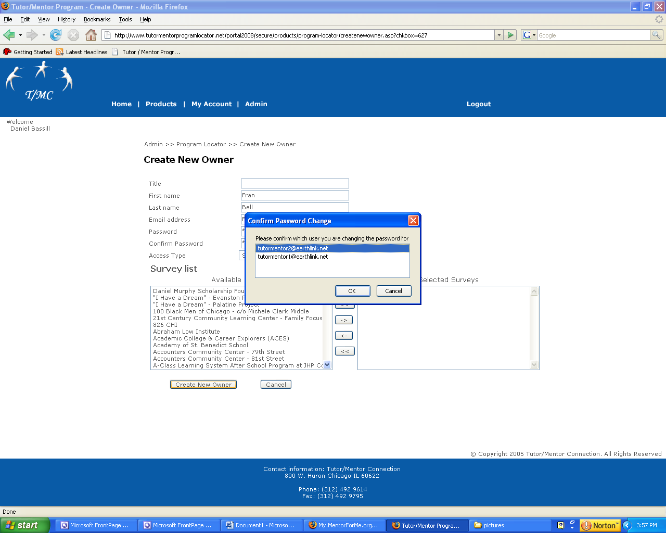

When I go to create new owner it is asking what email address is getting the password changed. I don’t want to change my password. This feature should only create a new owner.

When I changed another name this also pointed back to this “change my password” question.
When I click edit profile I get the error message below.
